import pandas as pd

import matplotlib.pyplot as plt

from statsmodels.tsa.arima.model import ARIMA

from statsmodels.tsa.seasonal import seasonal_decompose

# Load the dataset

data = pd.read_csv('Microsoft_Stock.csv')

# Convert the 'Date' column to datetime format

data['Date'] = pd.to_datetime(data['Date'], format='%m/%d/%Y %H:%M:%S')

# Set 'Date' as the index

data.set_index('Date', inplace=True)

# Select the 'Close' column as the time series data for ARIMA

series = data['Close']

# Visualize the closing price over time

plt.figure(figsize=(10, 6))

plt.plot(series)

plt.title('Microsoft Stock Closing Prices Over Time')

plt.xlabel('Date')

plt.ylabel('Closing Price (USD)')

plt.show()

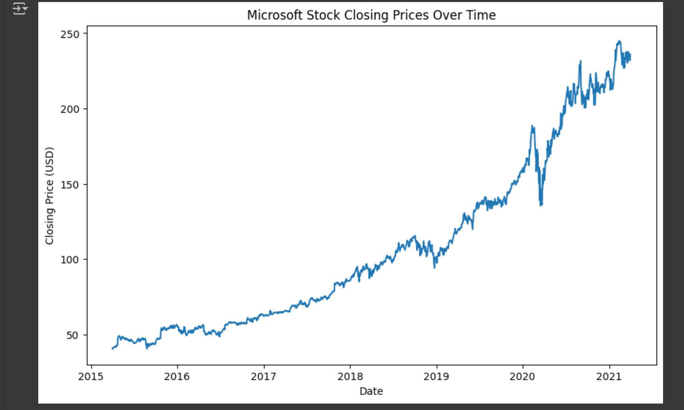

# Decompose the data (trend, seasonal, and residual components)

decomposition = seasonal_decompose(series, model='additive', period=30)

fig = decomposition.plot()

plt.show()

# Fit ARIMA model

model = ARIMA(series, order=(3, 1, 0)) # ARIMA order (p=3, d=1, q=0)

model_fit = model.fit()

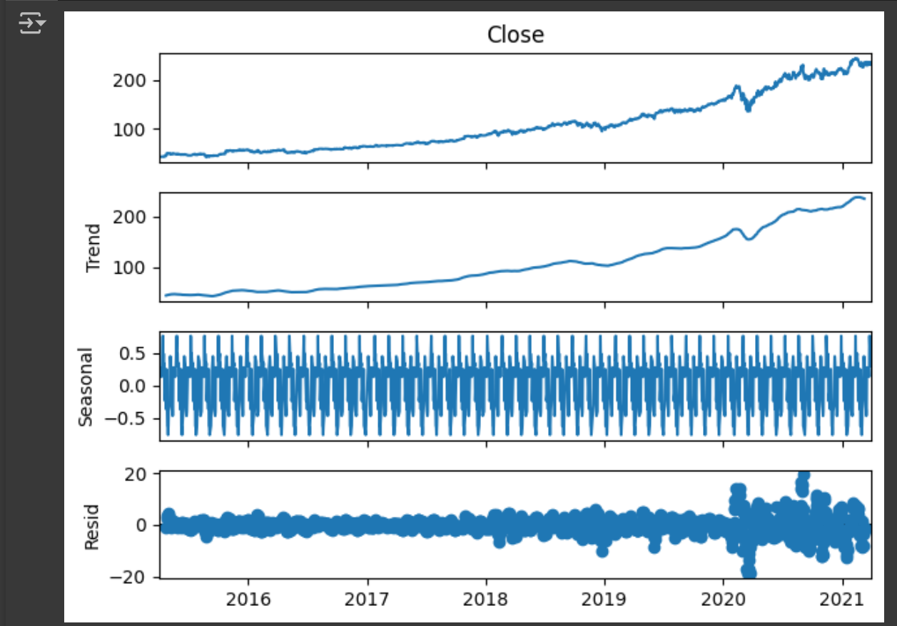

# Slice the historical data between 2010 and 2020

series_2010 = series['2010':]

# Forecast future values (starting from the end of data)

forecast_steps = 5 # Number of periods to forecast

forecast = model_fit.get_forecast(steps=forecast_steps)

forecast_values = forecast.predicted_mean

conf_int = forecast.conf_int()

# Plot the historical data along with the forecast

plt.figure(figsize=(10, 6))

# Plot the historical data

plt.plot(series_2010, label='Historical Data ')

# Plot forecast (after the last point data)

plt.plot(forecast_values.index, forecast_values, color='red', label='Forecast')

# Plot confidence intervals for the forecast

plt.fill_between(forecast_values.index, conf_int.iloc[:, 0], conf_int.iloc[:, 1], color='red', alpha=0.3)

# Set the title and labels

plt.title('Microsoft Stock Closing Price Forecast')

plt.xlabel('Date')

plt.ylabel('Closing Price (USD)')

# Add the legend

plt.legend()

# Show the plot

plt.show()

